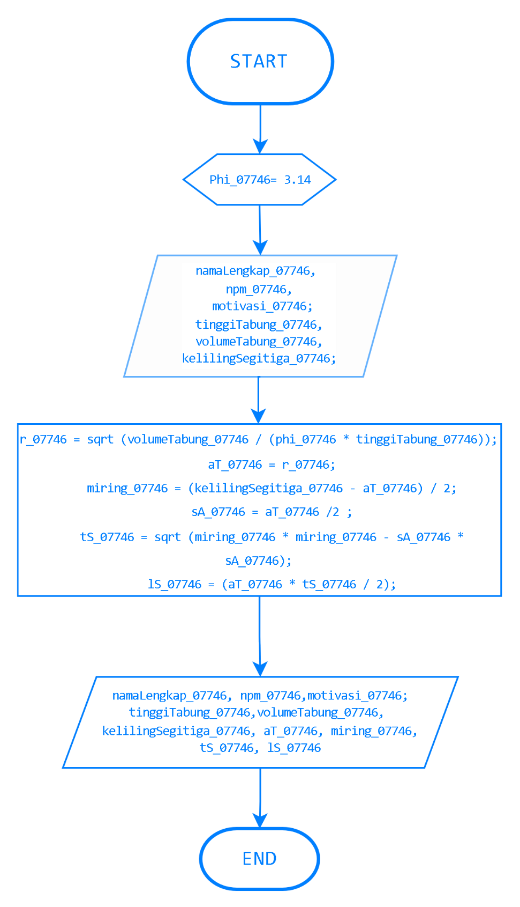

#include <iostream>

#include <string>

#include <cmath>

using namespace std;

int main () {

string namaLengkap_07746, npm_07746, motivasi_07746;

double tinggiTabung_07746, volumeTabung_07746, kelilingSegitiga_07746;

float phi_07746 = 3.14;

float r_07746, miring_07746, aT_07746, sA_07746, tS_07746, lS_07746;

cout << "Masukkan nama lengkap Anda: ";

cin >> namaLengkap_07746;

cout << "Masukkan NPM Anda: ";

cin >> npm_07746;

cout << "Motivasi Anda untuk masuk Teknik Informatika ITATS: ";

cin >> motivasi_07746;

cout << "Masukkan tinggi tabung :";

cin >> tinggiTabung_07746;

cout << "Masukkan volume tabung :";

cin >> volumeTabung_07746;

cout << "Masukkan keliling segitiga sama kaki: ";

cin >> kelilingSegitiga_07746;

r_07746 = sqrt (volumeTabung_07746 / (phi_07746 * tinggiTabung_07746));

aT_07746 = r_07746;

miring_07746 = (kelilingSegitiga_07746 - aT_07746) / 2;

sA_07746 = aT_07746 /2;

tS_07746 = sqrt (miring_07746 * miring_07746 - sA_07746 * sA_07746);

lS_07746 = (aT_07746 * tS_07746 / 2);

cout << "=======Informasi yang telah diinput========\n";

cout << "Nama lengkap : " << namaLengkap_07746 << endl;

cout << "NPM : " << npm_07746 << endl;

cout << "Motivasi masuk Teknik Informatika ITATS : " << motivasi_07746 << endl;

cout << "tinggi tabung :"<< tinggiTabung_07746 << endl;

cout << "volume tabung :"<< volumeTabung_07746 << endl;

cout << "keliling segitiga sama kaki: "<< kelilingSegitiga_07746 << endl;

cout << "===========Hasil Perhitungan===============\n";

cout << "Nilai Alas Segitiga :" << aT_07746 << endl;

cout << "Nilai Sisi Miring Segitiga :" << miring_07746 << endl;

cout << "Nilai tinggi Segitiga : " << tS_07746 << endl;

cout << "Luas segitiga sama kaki : " << lS_07746 << endl;

return 0;

}

